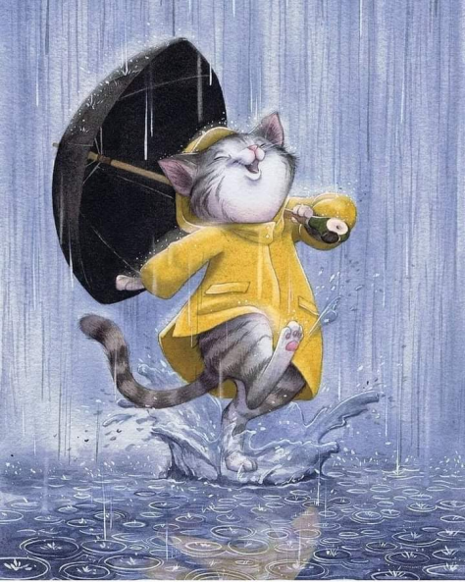

Lucifer is going to school

Lucifer¹ is a great but sometimes naughty cat. He is going to school² dancing in the rain³. He is wearing a yellow⁴ raincoat and an umbrella⁵ in his paw. He is singing a song⁶ about raining cats and dogs⁷. It is raining heavily⁸. Lucifer is jumping into the puddles⁹. I think when he gets to school he is going to be soaking wet. Cats don't like water¹⁰ very much but Lucifer is one of a kind. He has many friends¹¹ in school. He loves going there every day¹².

Ask questions:

FUTURE SIMPLE

I will get another hamster next week.
Will you get another hamster next week?
Yes, I will.
No, I won’t. (will not)

If I get another hamster next week, I will be very happy.
If David gets a good mark at Maths, …..
If mother has a day off, ……..
If dad buys a new car, ….
If the weather is good, ….

